Operating System (OS)
What it is:
An Operating System is a system software that acts as a bridge between the user and computer hardware. It controls and coordinates all parts of the computer.
OS is the heart of computer system.
Application programs requires an operating system to function and that OS can be windows, macOS, linux, android, etc.
All applications program send requests to OS for accessing hardware or resources.
Operating System (OS) is a very important system software.
Why it is needed:
Without an OS, hardware cannot understand user commands. The OS makes the computer usable, efficient, and secure by managing all resources.
How it works:
The OS runs continuously after the computer starts. It manages CPU, memory, files, and devices, allowing multiple programs to run smoothly and users to interact easily.
When it works:
It starts as soon as the computer is powered on (booting process) and runs until the computer is turned off.
Main Purpose / Functions:
- Process Management – Handles execution of programs.
- Memory Management – Allocates and frees memory.
- File Management – Organizes and controls data storage.
- Device Management – Controls input/output devices.
- User Interface – Provides command-line or graphical interaction.
- Security – Protects system and data from unauthorized access.
Examples:
Windows, Linux, macOS, Android, iOS.
In short:
The Operating System is the core software that makes hardware work, allows users to run programs, and ensures smooth, safe, and efficient operation of the entire computer system.
Main Parts / Layers of a Computer System: (Computer system structure):
- Hardware:
  - The physical components (CPU, memory, I/O devices).
  - Performs the actual computing and data processing.
- Operating System (System Software):
  - Acts as a bridge between hardware and users/programs.
  - Manages all system resources (CPU, memory, files, devices).
- System Programs:
  - Provide basic utilities and support functions (like file management tools, compilers, etc.).
- Application Programs:
  - Software designed for specific user tasks (MS Word, browsers, games, etc.).
- Users:
  - People or other systems that use the computer to perform tasks.
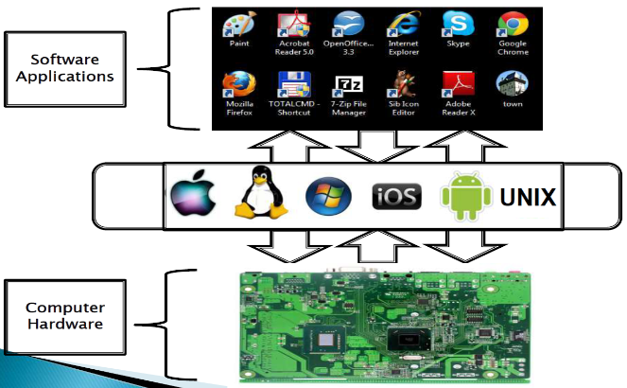

Goals of an Operating System:
- Primary Goals:
- Convenience (User Goal):
- Make the computer system easy, simple, and user-friendly to use.
- Users should not worry about hardware details.
(Example: GUI interfaces, file management, etc.)
- Efficiency (System Goal):
- Use hardware resources (CPU, memory, I/O) efficiently so that performance is maximized.
- Ensures fast and smooth system operation.
- Ability to Evolve (Development Goal):
- OS should be flexible and upgradable for future technologies or new hardware.
- Secondary (Technical) Goals:
- Resource Management:
- Manage and allocate CPU, memory, and devices among programs.
- Security and Protection::
- Protect data and system resources from unauthorized access.
- Multiprogramming & Multitasking:
- Allow multiple programs to run simultaneously without interference.
- Error Detection & Recovery:
- Detect hardware/software errors and take corrective actions.

Like Linux is more efficient in terms of memory, security, viruses and but not convenient to use that’s why windows has more users than Linux/uniux..

Types of OS
Type | Explanation (Concise) | Example
1. Batch Operating System | Executes a batch (group) of jobs automatically without user interaction. | IBM OS, early mainframe systems
2. Time-Sharing (Multitasking) OS | Allows multiple users/programs to share CPU time simultaneously. | UNIX, Windows
3. Multiprogramming OS | Runs many programs at once by keeping them in memory and switching CPU among them. | Linux, UNIX
4. Real-Time OS (RTOS) | Gives immediate response to inputs; used where timing is critical. | VxWorks, QNX, Embedded systems
5. Distributed OS | Manages multiple computers and makes them work as a single system. | LOCUS, Amoeba
6. Network OS | Manages and controls networked computers; allows resource sharing. | Novell NetWare, Windows Server
7. Mobile OS | Designed for smartphones and tablets with touch interface and limited resources. | Android, iOS

1. Batch Operating System
Concept:
Executes a batch (group) of jobs automatically.
Jobs are collected and processed in batches without user interaction.
Examples: IBM OS, early mainframe systems
Advantages:
- No manual intervention once jobs start.
- Efficient for repetitive, large tasks.
- Reduces idle CPU time.
Disadvantages:
- No interaction between user and system.
- Debugging is difficult.
- CPU may stay idle due to slow I/O devices.

2. Multiprogramming Operating System
Concept:
Runs many programs at once by keeping them in memory and switching CPU among them.
Multiple jobs are kept in memory; CPU switches among them for efficient use.
Examples: Linux ,UNIX
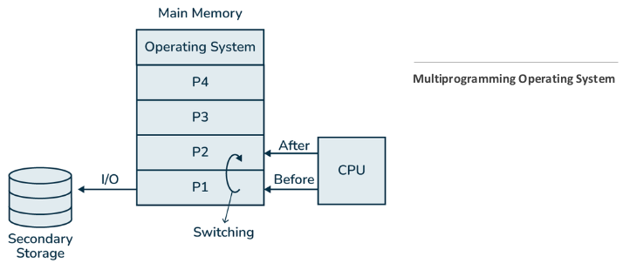
Advantages:
- High CPU utilization.
- Reduces idle time.
- Efficient use of memory and resources.
Disadvantages:
- Complex CPU scheduling.
- Needs proper memory management.
- Long waiting time for some jobs.

3. Multitasking (Time-Sharing) Operating System
Concept:
Allows multiple users/programs to share CPU time simultaneously.
Each process gets CPU for a fixed time (time quantum) to enable multi-user interaction.
Examples: UNIX, Windows

Advantages:
- Fast response to users.
- Better CPU sharing and utilization.
- Interactive and user-friendly.
Disadvantages:
- Requires powerful CPU and more memory.
- May cause delay if many users share system.
- Complex to manage.

4. Multiprocessing Operating System
Concept:
Uses two or more CPUs within one system to perform tasks simultaneously.
Examples: linux, windows, etc.
Advantages:
- True parallel processing.
- High speed and performance.
- Reliable — if one CPU fails, others work.
Disadvantages:
- Very expensive hardware.
- Complex system design.
- Synchronization is difficult.

5. Distributed Operating System
Concept:
Manages multiple computers and makes them work as a single system.
Multiple computers (nodes) connected via a network work as one system.
Examples: LOCUS, amoeba.
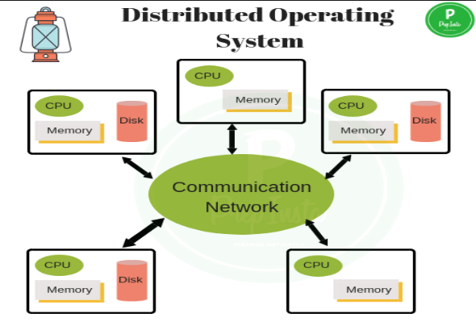
Advantages:
- High reliability (one system’s failure doesn’t affect others).
- Resource and data sharing.
- Scalable and faster communication.
Disadvantages:
- Expensive setup and maintenance.
- Dependent on network reliability.
- Complex software and communication management.

6. Real-Time Operating System (RTOS)
Concept:
Gives immediate response to inputs; used where timing is critical.
Used in time-critical systems requiring immediate and predictable responses.
The time interval required to process and respond to inputs is very small. This time interval is called response time.
Examples: VxWorks, QNX, Embedded systems
Types:
- Hard RTOS: Strict deadlines (missile, aircraft systems).
- Soft RTOS: Flexible deadlines (multimedia, automation).
Advantages:
- Provides accurate and quick response.
- Highly reliable and stable.
- Ideal for real-time applications.
Disadvantages:
- Expensive and complex design.
- Limited multitasking ability.
- Difficult to upgrade.

1. Hard Real-Time System
Definition:
A system where missing even a single deadline can cause system failure or disaster.
Example:
- Aircraft control systems
- Missile guidance systems
- Medical life-support systems
Key Points:
- Deadlines are strict and non-negotiable.
- Must give response within a fixed time.
- Used where accuracy and safety are critical.
Advantages:
- High reliability and precision.
- Suitable for mission-critical tasks.
Disadvantages:
- Very expensive and complex.
- Limited flexibility.

2. Soft Real-Time System
Definition:
A system where missing a deadline is tolerable but performance may degrade slightly.
Example:
- Multimedia systems
- Online transaction systems
- Video streaming or gaming
Key Points:
- Deadlines are important but not rigid.
- Focus on smooth performance rather than strict timing.
- Common in general-purpose real-time applications.
Advantages:
- Flexible and easier to design.
- Less costly than hard RTOS.
Disadvantages:
- May cause delays or data loss in heavy load.
- Not suitable for safety-critical systems.

User Operating System Interfaces:
User OS Interface is the bridge between the user and the computer system, enabling interaction through commands, visuals, or speech.
Types of User Interfaces:
- Command Line Interface (CLI):
Command Line Interface (CLI) allows the user to interact with the system using commands.
- Graphical User Interface (GUI):
Graphical User Interface (GUI) allows the user to interact with the system using graphical elements such as windows icons, menus.
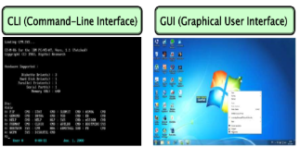
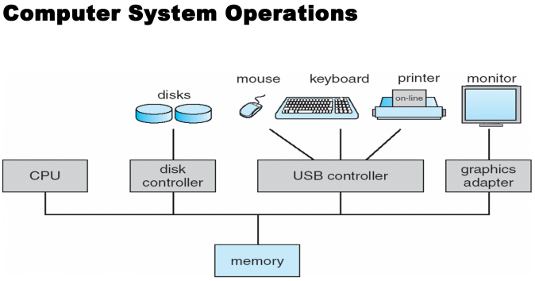
- I/O devices and the CPU can execute concurrently
- Each device controller is in charge of a particular device type
- Each device controller has a local buffer (local buffer temporary storage area in a computer’s memory (usually RAM) that is used to hold data temporarily while it is being transferred or processed by a specific program, device, or function.).
- CPU moves data from/to main memory to/from local buffers
- I/O is from the device to local buffer of controller
- Device controller informs CPU that it has finished its operation by causing an interrupt
How the OS manages Users and Tasks:
“The OS manages users by handling authentication, access, and privileges, and manages tasks by scheduling, executing, and coordinating multiple processes efficiently.”
Feature | Single User, Single Tasking | Single User, Multitasking
Number of Users | One | One
Number of Tasks | One at a time | Multiple at a time
Examples | MS-DOS, early phones | Windows, macOS, Android
Performance | Simple, limited | Efficient, flexible
Memory Use | Low | High
CPU Utilization | Low | High

“A Single User, Single Tasking OS allows one program at a time, while a Single User, Multitasking OS allows one user to perform several tasks simultaneously using CPU scheduling.”

Threads:
A thread is the smallest unit of CPU execution within a process.
Each thread shares the same memory and resources of its parent process but runs independently.
- multiple parts of the same program — called threads

Example (Simple):
When you use a web browser:
- One thread loads a webpage,
- Another thread downloads a file,
- Another thread plays a video —
➡️ All running simultaneously under the same browser process (multi-threading).
Multithreading:
Multithreading is an OS feature that allows multiple threads (multiple parts of same program) of a single process to run concurrently (simultaneously), improving CPU utilization and system performance.

OS Architecture:
Component | Description
1. User Interface (UI) | Provides interaction between user and system (CLI, GUI, etc.)
2. System Calls / API | Act as a bridge between user programs and OS kernel.
3. Kernel | Core part of OS — manages CPU, memory, I/O, and processes.
4. Device Drivers | Help the OS communicate with hardware devices.
5. File System | Manages how data is stored and retrieved.
6. Hardware Layer | Physical components like CPU, memory, and I/O devices.

Hardware = physical element of computer system.
Kernel = core part of an OS that directly communicates with the hardware, manages system resources i.e. CPU, memory, I/O, and processes,,, and provide a bridge between user applications and the hardware.
(OS → bridge b/w User and computer system , hardware)
(Kernel → bridge b/w user applications and computer hardware)
Shell = operating system shells use either a command-line interface (CLI) or graphical user interface (GUI).
User Applications = are computers program designed to perform group of coordinated functions, tasks, or activities for the benefit of the user.

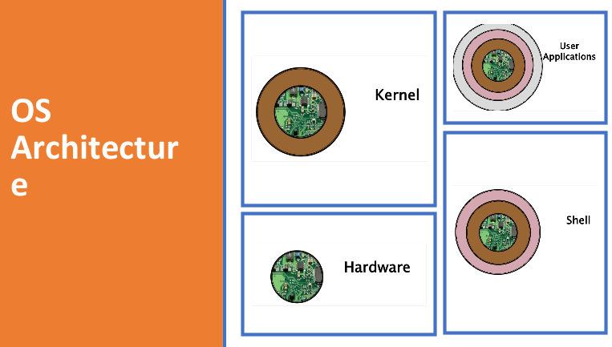

(Concept and explanation :

1. User Mode
Definition:
User Mode is the less-privileged mode in which application programs (like Word, PowerPoint, browsers, etc.) are executed.
Examples:
- MS Word
- PowerPoint
- Reading a PDF
- Browsing the Internet
Key Points:
- Has limited access to hardware resources.
- Runs application-level programs only.
- If a program in user mode needs hardware (e.g., printer, memory), it requests the kernel for service.
- Also called Restricted Mode, Slave Mode, or Less-Privileged Mode.
Purpose:
➡️ To protect the system from accidental or malicious access to hardware by applications.

🧠 2. Kernel Mode
Definition:
Kernel Mode is the privileged mode where the operating system kernel runs and has full access to all hardware components.
Key Points:
- Kernel acts as a bridge (middleware) between hardware and application software.
- Used for low-level, trusted functions like memory management, process control, and I/O operations.
- Only the OS kernel and device drivers operate here.
- Errors in kernel mode can crash the whole system because it has full control.
Relationship Between Both Modes:
Aspect | User Mode | Kernel Mode
Privilege (authority )Level | Low (Restricted) / Restricted / Slave mode. | High (Full Access) privileged / Master mode.
Who Runs Here (which program are controlled by them) | Applications | Operating System Kernel & Drivers
Hardware Access | Indirect (via Kernel) (Uses system calls to request kernel services.) | Direct
Purpose | Protect system from faulty programs | Manage hardware and system resources
Examples | MS Word, Browser, PDF Reader | Process Scheduler, Memory Manager
Failure Impact | Affects only the running program | Can crash the whole system
Purpose | To provide protection and stability by isolating applications from hardware. | To perform core system functions and manage all resources.

“Who runs here” = Which type of program or code executes in that mode.

Example:
When you open a Word file — it runs in User Mode.
When you save that file, Word requests the Kernel Mode (via a system call) to access the disk hardware safely.

In Summary:
User Mode = Safe zone for applications.
Kernel Mode = Power zone for OS.

Computer Startup Process (or booting process):
The computer startup (or booting process) is the sequence of steps a computer performs when it is powered on to load the Operating System (OS) into memory.

Steps:
- Power On → CPU gets control.
- BIOS/UEFI runs → checks hardware (POST – Power-On Self Test).
- Bootstrap program (in ROM) is loaded → it finds the OS.
- OS Kernel is loaded from storage into main memory (RAM).
- System is ready for user operations.
In short:
Booting = Loading the OS into memory to start the computer.
Bootstrap Program:
A bootstrap program is a small program stored in ROM (Read Only Memory) that runs when the computer is powered on.
It’s the first code executed by the CPU.

Function:
- Initializes hardware components.
- Loads the Operating System kernel from disk to RAM.
- Transfers control to the OS.
Think of it as:
“The program that wakes up the computer and calls the OS.”
Interrupt:
An interrupt is a signal sent to the CPU by hardware or software to get its attention when an immediate action is required.

Purpose:
To pause the current execution, handle the event, then resume the previous process.

Types:
Type | Source | Example
Hardware Interrupt | Sent by hardware devices. | Keyboard input, mouse click, I/O completion.
Software Interrupt | Generated by a program or OS service. | System call, divide-by-zero error.

In short:
Interrupts help the CPU respond quickly to urgent events.
Interrupt Handling:
The process by which the OS responds to an interrupt is called Interrupt Handling.

Steps:
- Interrupt signal is generated.
- CPU pauses current execution.
- Control is transferred to Interrupt Handler (Service Routine).
- Interrupt is serviced (e.g., read input).
- CPU returns to the previous task.
In short:
Interrupt Handling = Detect → Pause → Handle → Resume.

System Calls:
A system call is a request made by a user program to the operating system to perform a service that requires kernel-level access (like I/O, file, or process control).

Purpose:
User programs can’t access hardware directly, so they use system calls to communicate safely with the kernel.
In short:
System Call = Bridge between User Mode and Kernel Mode.
Types of System Calls:
Type | Purpose / Example
Process Control | Create, execute, or terminate processes. e.g., fork(), exit(), wait()
File Management | Create, read, write, delete, open, close files. e.g., open(), read(), write()
Device Management | Request or release devices. e.g., ioctl(), read(), write()
Information Maintenance | Get or set system data. e.g., getpid(), settime()
Communication | Exchange information between processes. e.g., pipe(), send(), recv()

Summary Table:
Concept | Purpose | Example
Computer Startup | Load OS into memory to start system. | Windows/Linux boot sequence.
Bootstrap Program | First program in ROM that loads OS kernel. | BIOS, UEFI, GRUB.
Interrupt | Signal to CPU for urgent attention. | Keyboard input, divide-by-zero.
Interrupt Handling | Process of responding to interrupts. | Printer or disk interrupt.
System Call | User program requests OS service. | read(), fork(), exit().
Types of System Calls | File, Process, Device, Info, Communication. | open(), write(), pipe().

Only one interrupt is generated per block, rather than the one interrupt per byte.
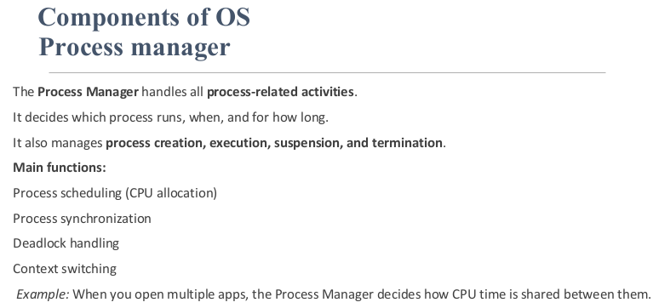
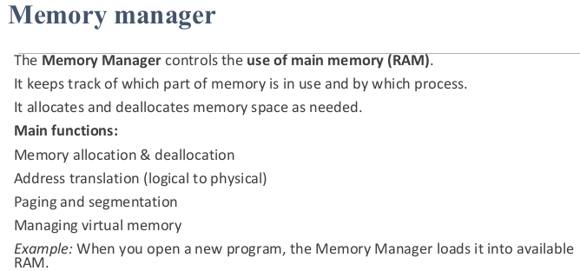
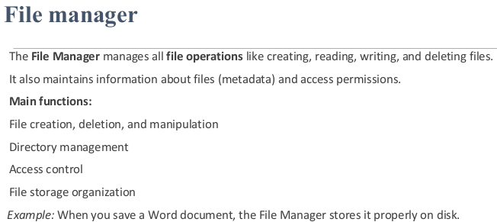
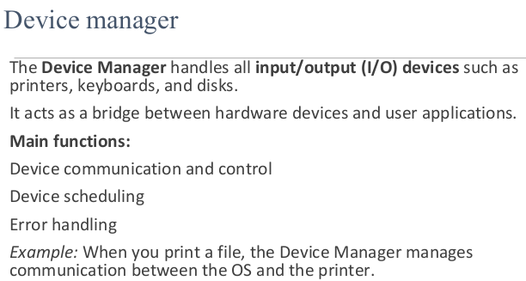
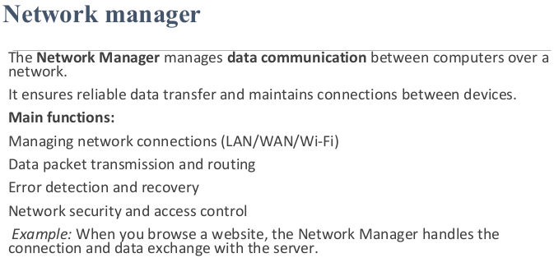

Virtual Machine (VM):
A Virtual Machine is a “computer inside a computer.”
A Virtual Machine (VM) is a software-based simulation of a computer system that behaves like a real physical computer.
It runs an operating system and applications just like a real machine, but it is created and managed by another software called a Hypervisor.
it has its own CPU, memory, storage, and operating system — but it runs inside another physical machine.
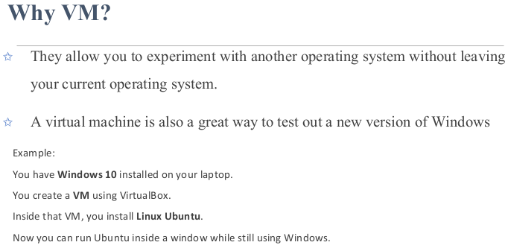

How it Works:
- The Hypervisor (or Virtual Machine Monitor) divides the physical hardware (CPU, memory, disk, etc.) into multiple virtual environments.
- Each VM runs its own Operating System (called a guest OS) independent of others.
- The real hardware has a host OS (like Windows, Linux, macOS).

Advantages:
✅ Efficient hardware utilization (one PC can run many OSs)
✅ Isolation — one VM crash doesn’t affect others
✅ Easier software testing (different OSs on one machine)
✅ Supports system backup, recovery, and portability

Disadvantages:
❌ Slower performance than real hardware
❌ Needs more RAM and CPU power
❌ Complex management and setup
❌ Requires large disk space
